**PROJECT REPORT**

**Loan Default Prediction**

*Submitted towards the partial fulfillment of the criteria for award of Genpact Data Science Prodegree by Imarticus*

*Submitted By:*

*Naveen Mechu*

*Course and Batch: DSP Feb 2020*



# Abstract

**Keywords**

*Disclaimer: *Data shared by the customer is confidential and sensitive, it should not be used for any purposes apart from capstone project submission for DSP. The Name and demographic details of the enterprise is kept confidential as per their owners’ request and binding.*

# Acknowledgements

I got opportunity to express my gratitude to everyone who supported me throughout the course of this project. I thankful for their aspiring guidance, invaluably constructive criticism and friendly advice during the project work. I am sincerely grateful to them for sharing their truthful and illuminating views on a number of issues related to the project.

Further, fortunate to have Dr. Vinod Kumar Murti & Mr. Viswanath Kanamarlapudi as mentors. They have readily shared there immense knowledge in data analytics and guide me in a manner that the outcome resulted in enhancing my data skills.

I wish to thank, all the faculties, as this project utilized knowledge gained from every course that formed the DSP program.

I certify that the work done by me for conceptualizing and completing this project is original and authentic.

Date: Aug 20, 2020 Naveen Mechu

Place: Jaipur

# Certificate of Completion

I hereby certify that the project titled “Pro Degree in Data Science” was undertaken and completed under my supervision by Naveen Mechu from the batch of DSP29 (Feb 2020)

Mentor 1: Dr. Vinod Kumar Murti

Date: Aug 20, 2020

Place –

Table of Contents

**Abstract2**

**Acknowledgments2**

**Certification of Completion3**

**Business Understanding5**

**Problem Understanding5**

**Data Understanding5**

**Hardware and Software used6**

**Methodology followed6**

**Data Preparation & understanding7**

**Data extraction & cleaning7**

**Missing value treatment7**

**Data formatting8**

**Handling outliers**9

**Feature engineering9**

**Data splitting9**

**Balancing10**

**Model building**10

**Logistic Regression without balancing10**

**Logistic Regression after balancing11**

**Logistic regression with grid search12**

**Random forest12**

**Navie Bayes13**

**KNN14**

**SVM14**

**Conclusion14**

**References15**

**Business Understanding:**

Key idea behind Banking is handling money for other people. Services offered by banks can be broadly categorized as deposit and lend money based upon some mutually agreed conditions. It is almost certain that it will have to repay depositors, but it is not certain that it will be repaid by borrowers. To overcome loss of non-repayment banks uses different approaches and categories based of different parameters such as total debt, annual income, purpose of loan, etc. to know risk factor and based on risk factor bank decides to offer or decline loan.

**Problem Understanding**

In general, whenever an individual/corporation applies for a loan from a bank (or any loan issuer), their credit history undergoes a rigorous check to ensure that whether they are capable enough to pay off the loan.

The issuers have a set of models and rules in place which takes information regarding their current financial standing, previous credit history and some other variables as input and output a metric which gives a measure of the risk that the issuer will potentially take on issuing the loan. The measure is generally in the form of a probability and is the risk that the person will default on their loan (called the probability of default) in the future.

Under this project XYZ Corp. is looking to build some model based on machine learning which can predict probability of default more accurately.

**Data Understanding**

XYZ Corp. provided files containing complete loan data for all loans issued from 2012 to 2015 having 855969(Observations) consumers with 73(Variables) parameters. Summary of files submitted by XYZ Corp is under-

|  |  |  |  |  |
| --- | --- | --- | --- | --- |
| **Sr no** | **File Name** | **File Format** | **File Size** | **Remark** |
| 1 | DataDictionary-14-10-17 | Excel | 13KB | Description of variables |
| 2 | XYZCorp_LendingData | Txt | 352,282 KB | Data of 855969 borrowers |
| 3 | Imarticus Problem Statement-14-10-17 | Word | 518 KB | Problem statement of XYZ Corp. |

**Hardware and Software used in project**

1. **Hardware**

OS- Windows 10 (64 bit).

RAM- 4 GB

1. **Software**

Python 3.7(Jupyter Notebook IDE)

Anaconda

1. **Libraries of Python**

Pandas

Numpy

Seaborn

Matplotlib

Scipy

SKlearn

Plotly, Cuflinks

**Methodology followed**

This study implements the standard data mining methodology known as CRISP- DM model. CRISP-DM is freely available and the leading methodology in data mining.

# DATA PREPARATION AND UNDERSTANDING

Data preparation is the process of cleaning and transforming raw data prior to processing and analysis. It is an important step prior to processing and often involves reformatting data, making corrections to data and the combining of data sets to enrich data.

One of the first steps we engaged in was to outline the sequence of steps that we will be following for our project. Each of these steps are elaborated below

## Data Extraction and Cleaning:

Data cleaning is the process of detecting and correcting (or removing) corrupt or inaccurate records from dataset and refers to identifying incomplete, incorrect, inaccurate or irrelevant parts of the data and then replacing, modifying, or deleting the dirty or coarse data.

* **Missing Value Analysis and Treatment**

Data consist of a lot of missing values; code used for missing values is as under-

missing_value_cnt = df.isnull().sum()

percentage = 100 * df.isnull().sum() / len(df)

missing_values_table = pd.concat([missing_value_cnt.sort_values(ascending=False), percentage, data_types], axis=1 , sort= False)

print(missing_values_table)

Dropped Variables having more than 80 % missing values using below code-

df = df.drop(["dti_joint", "verification_status_joint", "annual_inc_joint", "il_util",

"mths_since_rcnt_il", "total_bal_il" , "inq_last_12m", "open_acc_6m", "open_il_6m", "open_il_24m", "open_il_12m", "open_rv_12m", "open_rv_24m", "max_bal_bc",

"all_util","inq_fi","total_cu_tl","desc","mths_since_last_record"], axis=1)

* **Data Formatting**

Data encoding is done to clean and convert some categorical variable in numeric variables.

df['grade'] = df['grade'].map({'A':7,'B':6,'C':5,'D':4,'E':3,'F':2,'G':1})

df['application_type'] = df['application_type'].map({'INDIVIDUAL':0,'JOINT':1})

df['initial_list_status'] = df['initial_list_status'].map({'f':0,'w':1})

df['pymnt_plan'] = df['pymnt_plan'].map({'n':0,'y':1})

df["emp_length"]=df["emp_length"].replace({'years':'','year':'','':'','<':'','\+':'','n/a':'0'}, regex = True)

df["term"] = df["term"].replace({"months": ''} , regex = True)

**Date format of below mentioned variables is converted from Jan-2015 to 201501**

issue_d

earliest_cr_line

last_credit_pull_d

last_pymnt_d

* **Data Type conversion of variable**

Data type of issue_d, earliest_cr_line, last_credit_pull, _d & last_pymnt_d is changed from “object” to int(numeric).

* **Imputation of Missing values**

1. Variables mths_since_last_major_derog & mths_since_last_delinq have more missing values these are actually those consumers who never derogated & deliquesced. These variables provide no. of months since last derogated or deliquesced. So replacing missing value from maximum value is better approach in this case.
2. Missing values for last_pymnt_d, last_credit_pulled_d & emp_length are imputed by min value as they are cases of never paid and not employeed.
3. Impute other missing values by median.

* **Handling Outliers**

Outliers are data points that differ significantly from other observations. An outlier may be due to variability in the measurement or it may indicate experimental error.

Dataset have a lot of outliers, none of the conventional approach is giving better results. Tried methods are Z score, IQR and DBSCAN method. Finally tried to avoid variables having more no of outliers.

* **Drop unrelated features**

Below mentioned features are dropped-

|  |  |
| --- | --- |
| **Features name** | **Remark** |
| id | Of no use in prediction of loan status. |
| member_id | Of no use in prediction of loan status. |
| emp_title | Has so many distinct and missing values also not significant |
| ZIP code | The last 3 numbers of the zip code are not provided |
| Title | Title is same as Purpose |

## Feature Engineering

Feature engineering is the process of transforming raw data into features that better represent the underlying problem to the predictive models, resulting in improved model accuracy on unseen data.

Approach used for feature engineering are-

## Data splitting for Model

## Splitting of data is process of dividing data in train and test on the basis data and domain or client requirement. In this problem data is divided on the basis of Issued date. Records upto June 2015 are train and July onwards in test.

## Balance Training data

Dataset is highly imbalanced. The challenge of working with imbalanced dataset is that most machine learning techniques will ignore, and in turn have poor performance on, the minority class, although typically it is performance on the minority class that is most important. There are multiple techniques to handle imbalanced dataset, such as –Random Under sampling, Random Oversampling, SMOTE(Synthetic Minority oversampling technique). Under This problem SMOTE is giving better results. Splitting of data is process of dividing data in train and test on the basis data and domain or client

# 3: Model Building

As the problem is to classify that consumer will do default or not, So it classification problem. Below algorithms are used under this project.

1. **Logistic Regression without balancing**

Logistic regression can be used also to solve problems of classification. In general, logistic regression classifier can use a linear combination of more than one feature value or explanatory variable as argument of the sigmoid function. The corresponding output of the sigmoid function is a number between 0 and 1. The middle value is considered as threshold to establish what belong to the class 1 and to the class 0. In particular, an input producing an outcome greater than 0.5 is considered belongs to the class 1. Conversely, if the output is less than 0.5, then the corresponding input is classified as belonging to class 0.

Logistic algorithm is giving accuracy .999 Accuracy which far good but here dataset is not balanced so precision matters more.

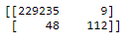

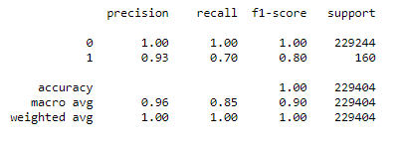

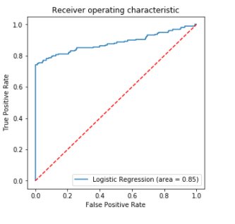

1. **Logistic Regression after balancing**

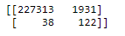

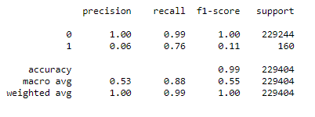

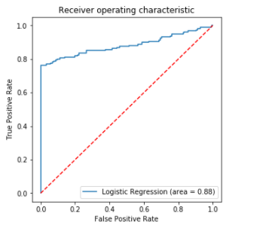

Here recall increases but precision which may or may not be acceptable depending upon problem.

1. **Logistic Regression with Grid search**

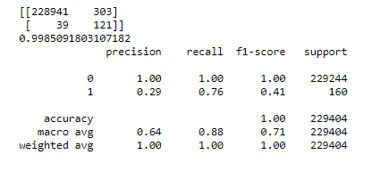

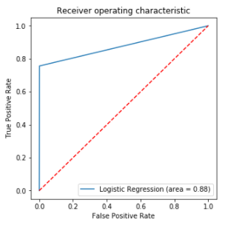

1. **Random Forest**

Random forests or random decision forests are an ensemble learning method for classification, regression and other tasks that operate by constructing a multitude of decision trees at training time and outputting the class that is the mode of the classes or mean prediction of the individual trees.

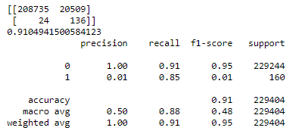

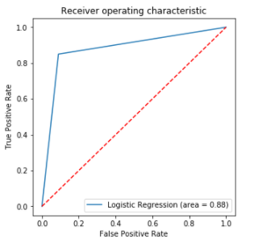

1. **Navie Bayes**

Naive Bayes classifiers are a family of simple "probabilistic classifiers" based on applying Bayes' theorem with strong independence assumptions between the features. They are among the simplest Bayesian network models. But they could be coupled with Kernel density estimation and achieve higher accuracy levels.

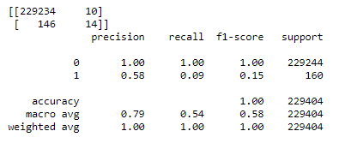

1. **KNN Classifier**

k-NN is a type of instance-based learning, or lazy learning, where the function is only approximated locally and all computation is deferred until function evaluation. Since this algorithm relies on distance for classification.

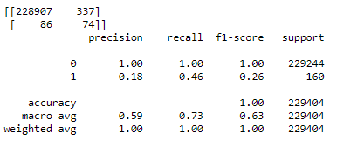

1. **SVM Classifier**

An SVM model is a representation of the examples as points in space, mapped so that the examples of the separate categories are divided by a clear gap that is as wide as possible. New examples are then mapped into that same space and predicted to belong to a category based on the side of the gap on which they fall.

In addition to performing linear classification, SVMs can efficiently perform a non-linear classification using what is called the kernel trick, implicitly mapping their inputs into high-dimensional feature space.

**Conclusion**

I have acquired the result of an accurate value of loan default prediction i.e. 99.9% using a Logistic regression with grid search where recall for minority class is 76%. And if we compromise with accuracy of non-defaulters, in that case Random forest algorithm gives better results. The Random forest algorithm will provide better performance with many training data, but speed during testing and application will still suffer. Usage of more pre-processing and deep learning techniques can further improve model.

**Reference**

1. https://en.wikipedia.org/wiki/Support_vector_machine
2. https://en.wikipedia.org/wiki/Naive_Bayes_classifier
3. https://scikit-learn.org/stable/modules/generated/sklearn.ensemble.RandomForestClassifier.html
4. https://en.wikipedia.org/wiki/Feature_extraction
5. KhyatiChaudhary, JyotiYadav, BhawnaMallick, “ A review of Fraud Detection Techniques: Credit Card”, International Journal of Computer Applications Volume 45– No.1 2012
6. https://towardsdatascience.com/the-random-forestalgorithm-d457d499ffcd
7. https://en.wikipedia.org/wiki/Dimensionality_reduction#:~:text=Dimensionality%20reduction%2C%20or%20dimension%20reduction,close%20to%20its%20intrinsic%20dimension.
8. https://clevertap.com/blog/how-to-treat-missing-values-in-your-data-part-ii/
9. https://www.analyticsvidhya.com/blog/tag/missing-values-treatment/